Iowa Nepalese Association (INA)
INA Town Hall Meeting – 950 Warrior Lane, Waukee, IA. 02/26/2017 1:00 PM – 3:00 PM
Meeting Purpose: Town Hall Meeting to discuss about Earthquake Relief Disbursement Fund and kickoff IAA Festival 2017.
Invitees: INA Community Members
Attendees Present:

Atma R Upreti
Sarvendra Agrahari
Pradip R Sthapit
Surendra Bajracharya
Prajita Sharma Dahal
Sanjeev Dahal
Kapil Limbu
Bikram Shrestha
Madan Thapa
Bishwash Bhattarai
Kailash M Kayastha
Ram M Pathak
Krishna Pandit
Sanjay Shrestha
Sanjay Ghimire
Shristi Shrestha
Rachayita Karki
Prajwol Gopali

Agenda and Meeting Minutes:
- Earthquake Relief Disbursement Team Report.
  - Earthquake Relief Fund Disbursement Committee presented the report on current status of the Himalayan School rebuilding project.
    - Team shared the effort that has been put forth for this project by several groups as of now.
    - Team shared the number of classrooms that can be built with INA fund.
    - Team also shared some concerns on the current estimates and report provided by Dilip Ghasi to the Committee that conflicts with the primary agreement/understanding that INA had.
  - INA members available during the Town Hall reviewed and discussed about the report provided by the Earthquake Relief Fund Disbursement Committee.
    - INA members discussed about how this project got selected, initiated and what level of effort was invested from all affiliated parties. Tireless effort from Jyoti Khadka, Dilip Ghasi, NRNA, Sachet Upadhya and more importantly our Earthquake Relief Fund Disbursement Committee was applauded by INA members.
    - INA members individually weighed in on the pros and cons about the current estimates and report on rebuilding Himalayan School.
    - INA members expressed their concerns and also discussed if providing the fund to Himalayan School will be justifiable to donors as INA’s impact will be minimal than expected.
    - INA members brought up that we have been holding the relief fund for too long and needs to be disbursed.
  - As decision made from last Town Hall meeting if Earthquake Relief Fund Disbursement Committee didn’t process the fund for School rebuilding by beginning of 2017, next town hall meeting will decide that fund will be provided either to Prime Minister Earthquake Relief Account or NRNA Earthquake Relief account. As part of the previous Town Hall decision and changes in the circumstances we are in as per the report, INA members voted and following decision is made : ‘Iowa Nepalese Association will provided the remaining Earthquake Relief Fund to NRNA in a consent that the fund has to be used for Earthquake Relief related projects. ’
    - Earthquake Relief Fund Disbursement Committee will still steer the process to handover the fund to NRNA.
    - Earthquake Relief Fund Disbursement Committee will be dissolved once the fund is handed over to NRNA and if we decide to follow up with NRNA in future then current INA board will coordinate the process.

  - Earthquake related reports and documents are available in INA website. Link : http://www.iowanepaleseassociation.org/EarthQuakeRelief/documents/

- Iowa Asian Alliance Festival 2017 Kickoff.
  - Task Team created for IAA 2017.
    - Village Leader: Pradip R Sthapit
    - Co- Village Lead: Bipin Tamrakar
    - Cultural Tent: Madan Thapa
    - Cultural Dance/ Fashion Show: Rachayita Karki/ Shristi Shrestha/ Aabristi Khadka
  - INA members have suggested not to include Food this year.
    - INA members in the Town Hall have strongly recommended not to include Food this year.
    - Only one cultural tent should be booked.
    - INA current board will revisit the suggestions and make decisions.

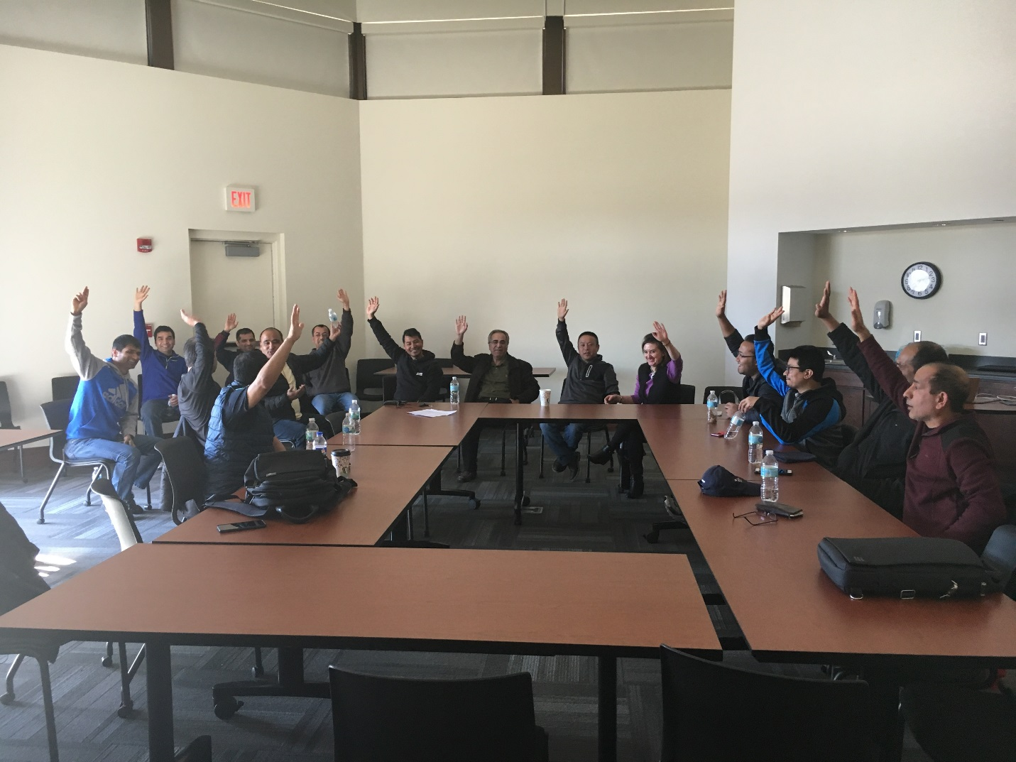Town Hall Meeting attendees raising their hands in support of decision made on Earthquake Relief Fund Disbursement.

Please let us know if you have any questions.
Thanks,
Prajwol Gopali
General Secretary
Iowa Nepalese Association (INA)

