Dear Sirs,

As per our Khopachagu Site visit and frequent communication with local authorities we found following circumstances and we have prepared report for the site.

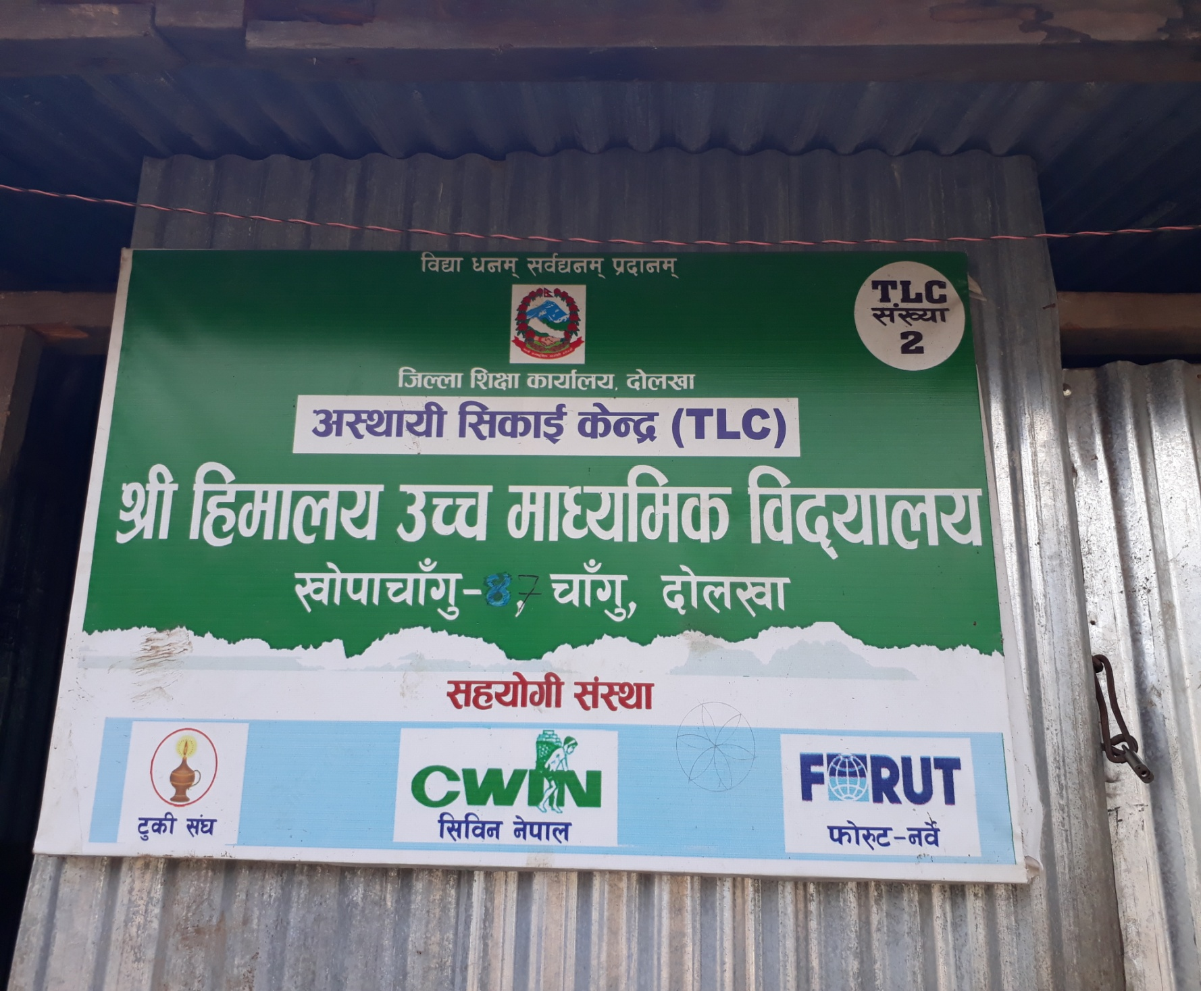

The School is higher Secondary (+2) which needs 12 classrooms for grade 1-12. If we calculate pre-primary classes the school needs minimum 15 rooms only for classrooms if they have only one section each class. For office and labs, a higher secondary school needs 20 rooms for easy operation. Currently the school has only temporary rooms except 4 roomed RCC building (which needs repair).

Proposed site for CWIN Nepal

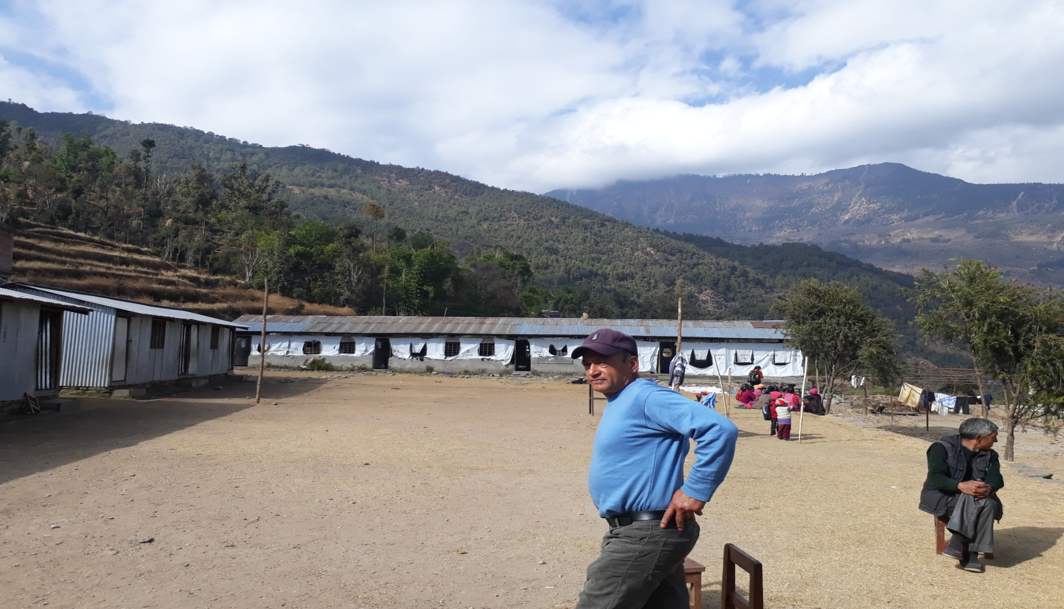

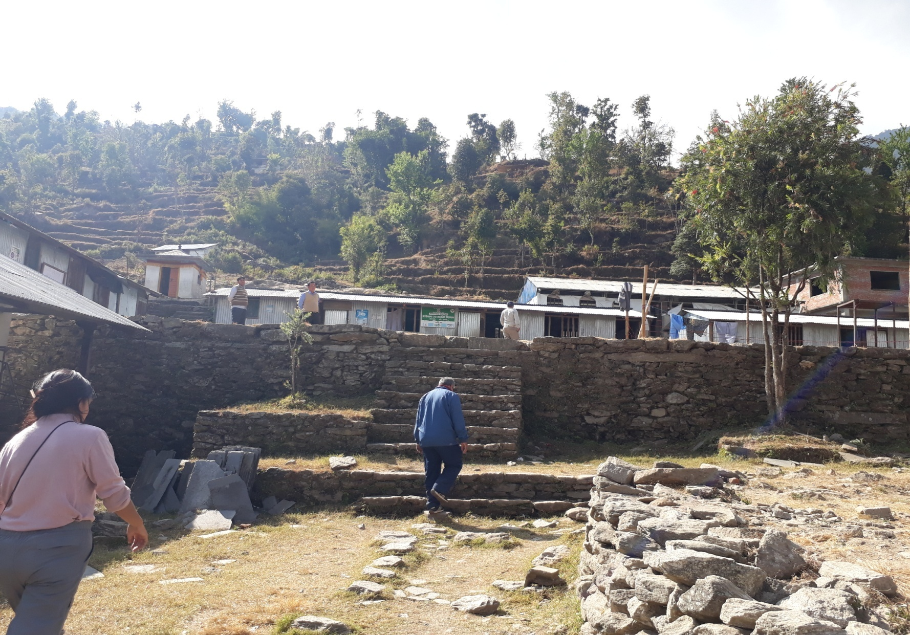

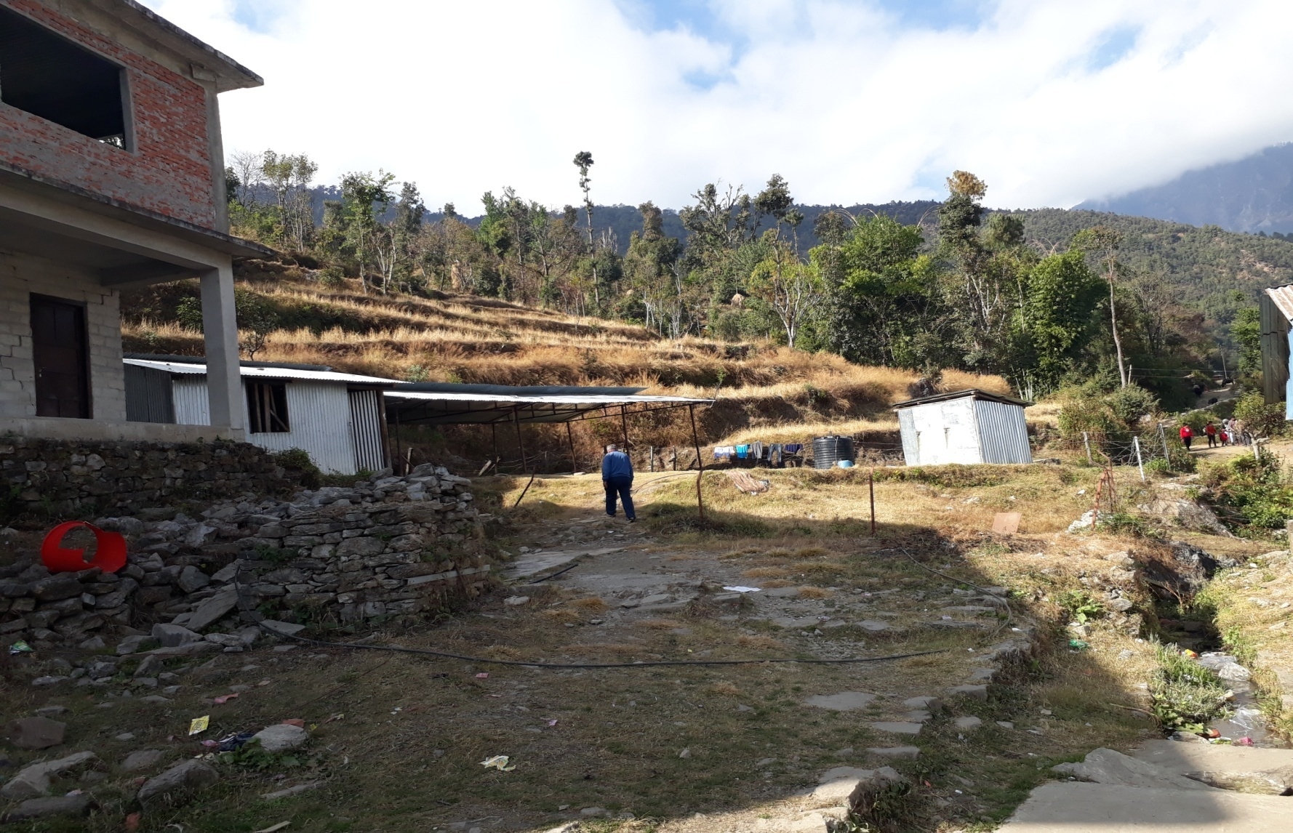

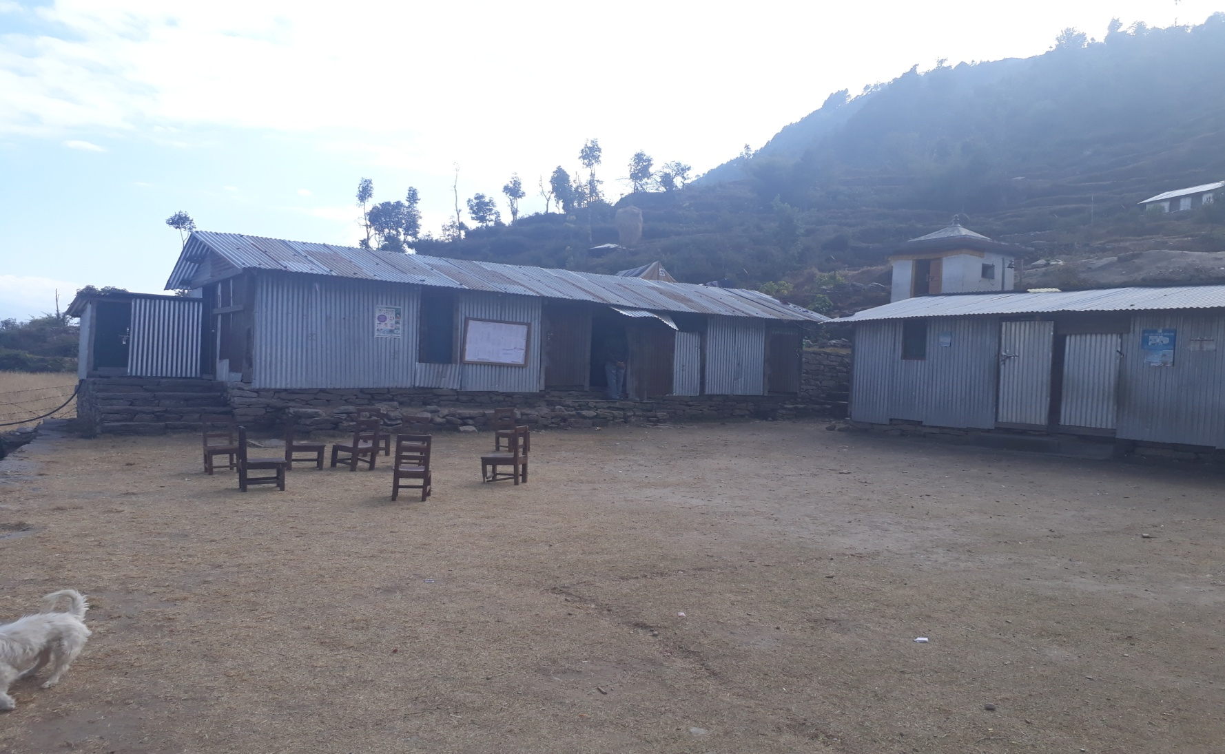

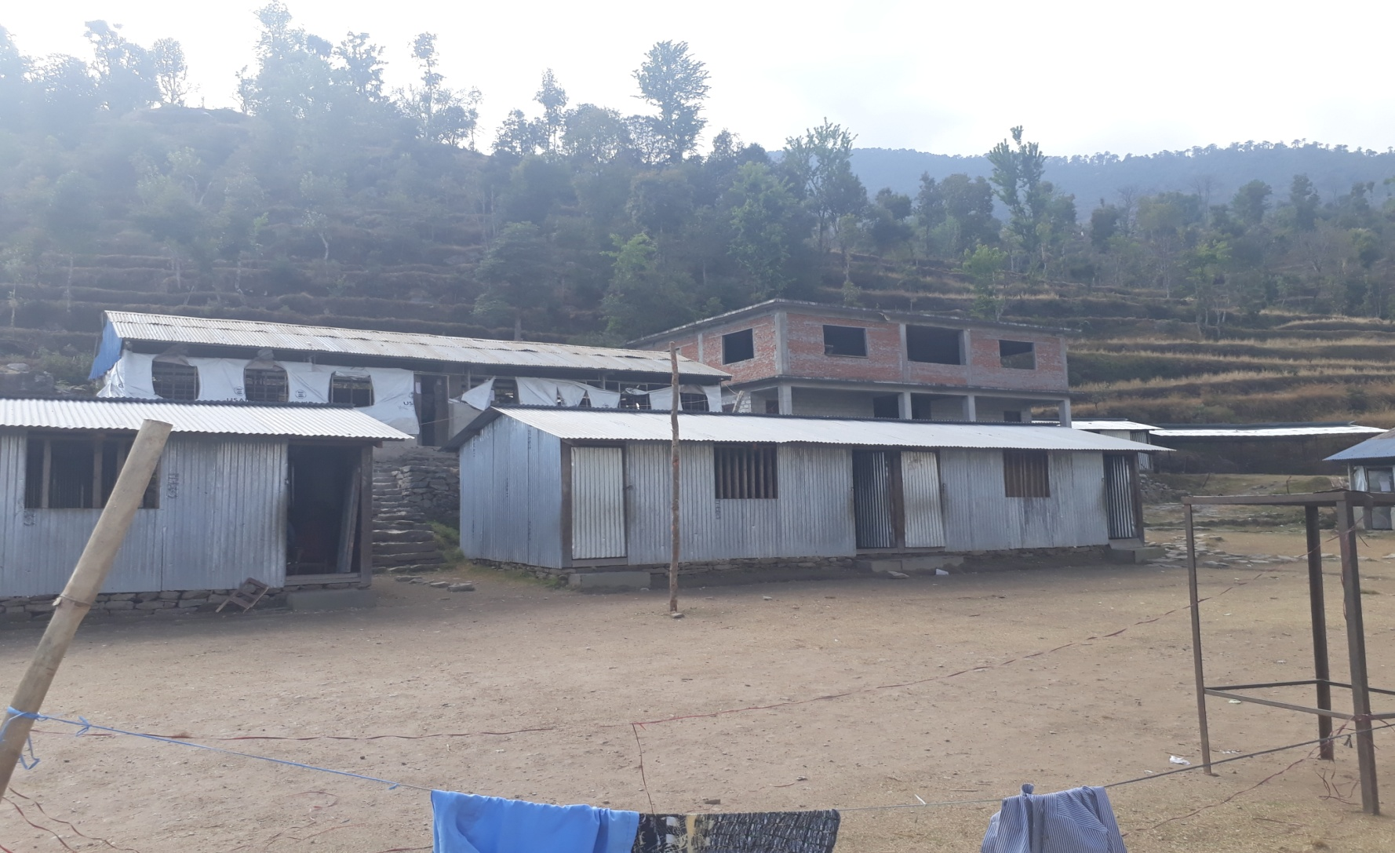
4 Roomed RCC Building (Need structure repair)

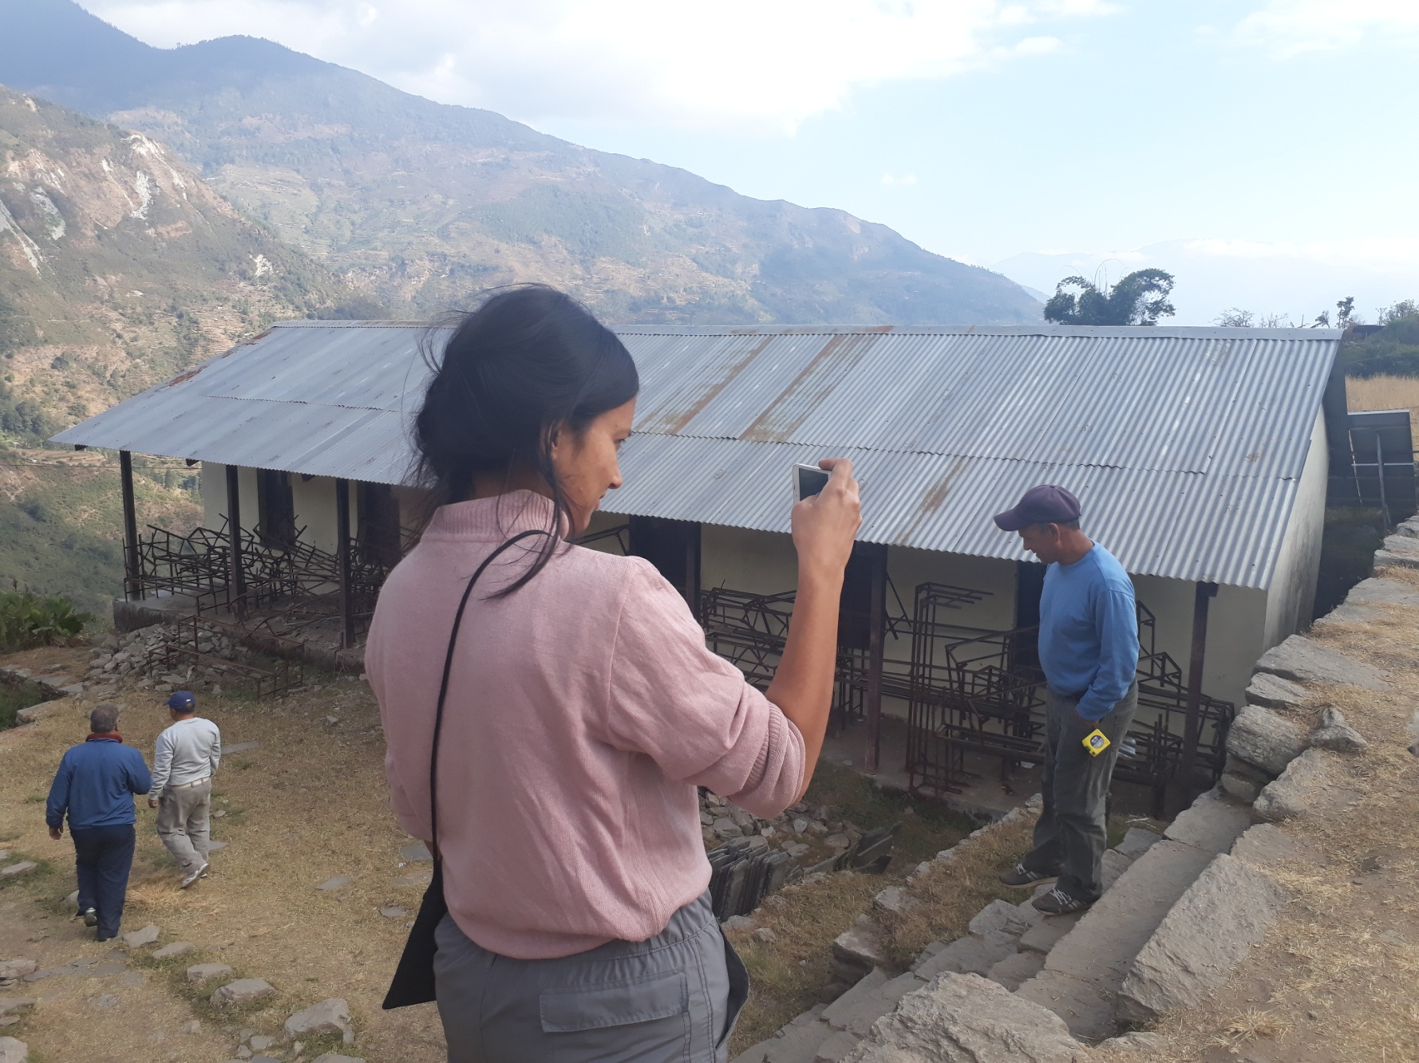
Devastated Building (needs to demolish) Proposed for our work

As per local transporter (truck and tractors) there is better way from Sorung Khola to Khopachagu via Bigu. This road is better than the road which we followed 23rd January.
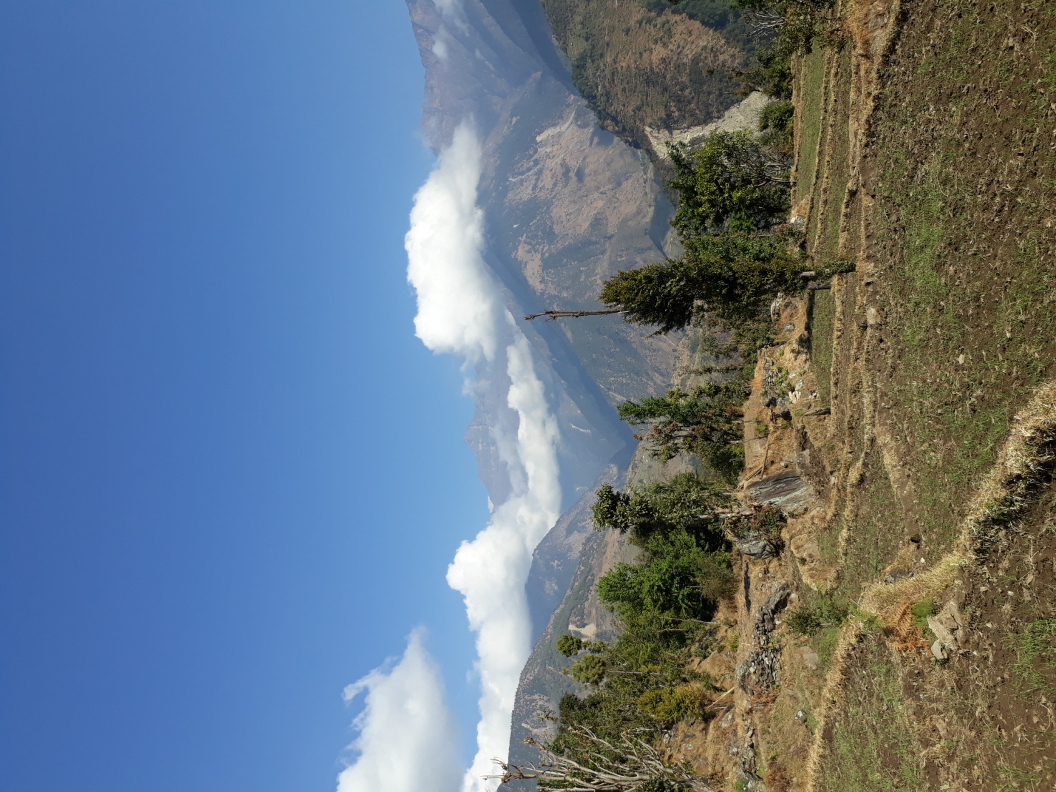
Bigu
Sorung Khola

Bigu

There is not any place to store goods at Sorung Khola. If we contact and arrange with Singati Hydropower Project, the temporary store may be available. Otherwise we have to arrange at Singati Bazar which is 9 Km. Before from Sorung Khola.
Sorung Khola (The last point for transport from Kathmandu)

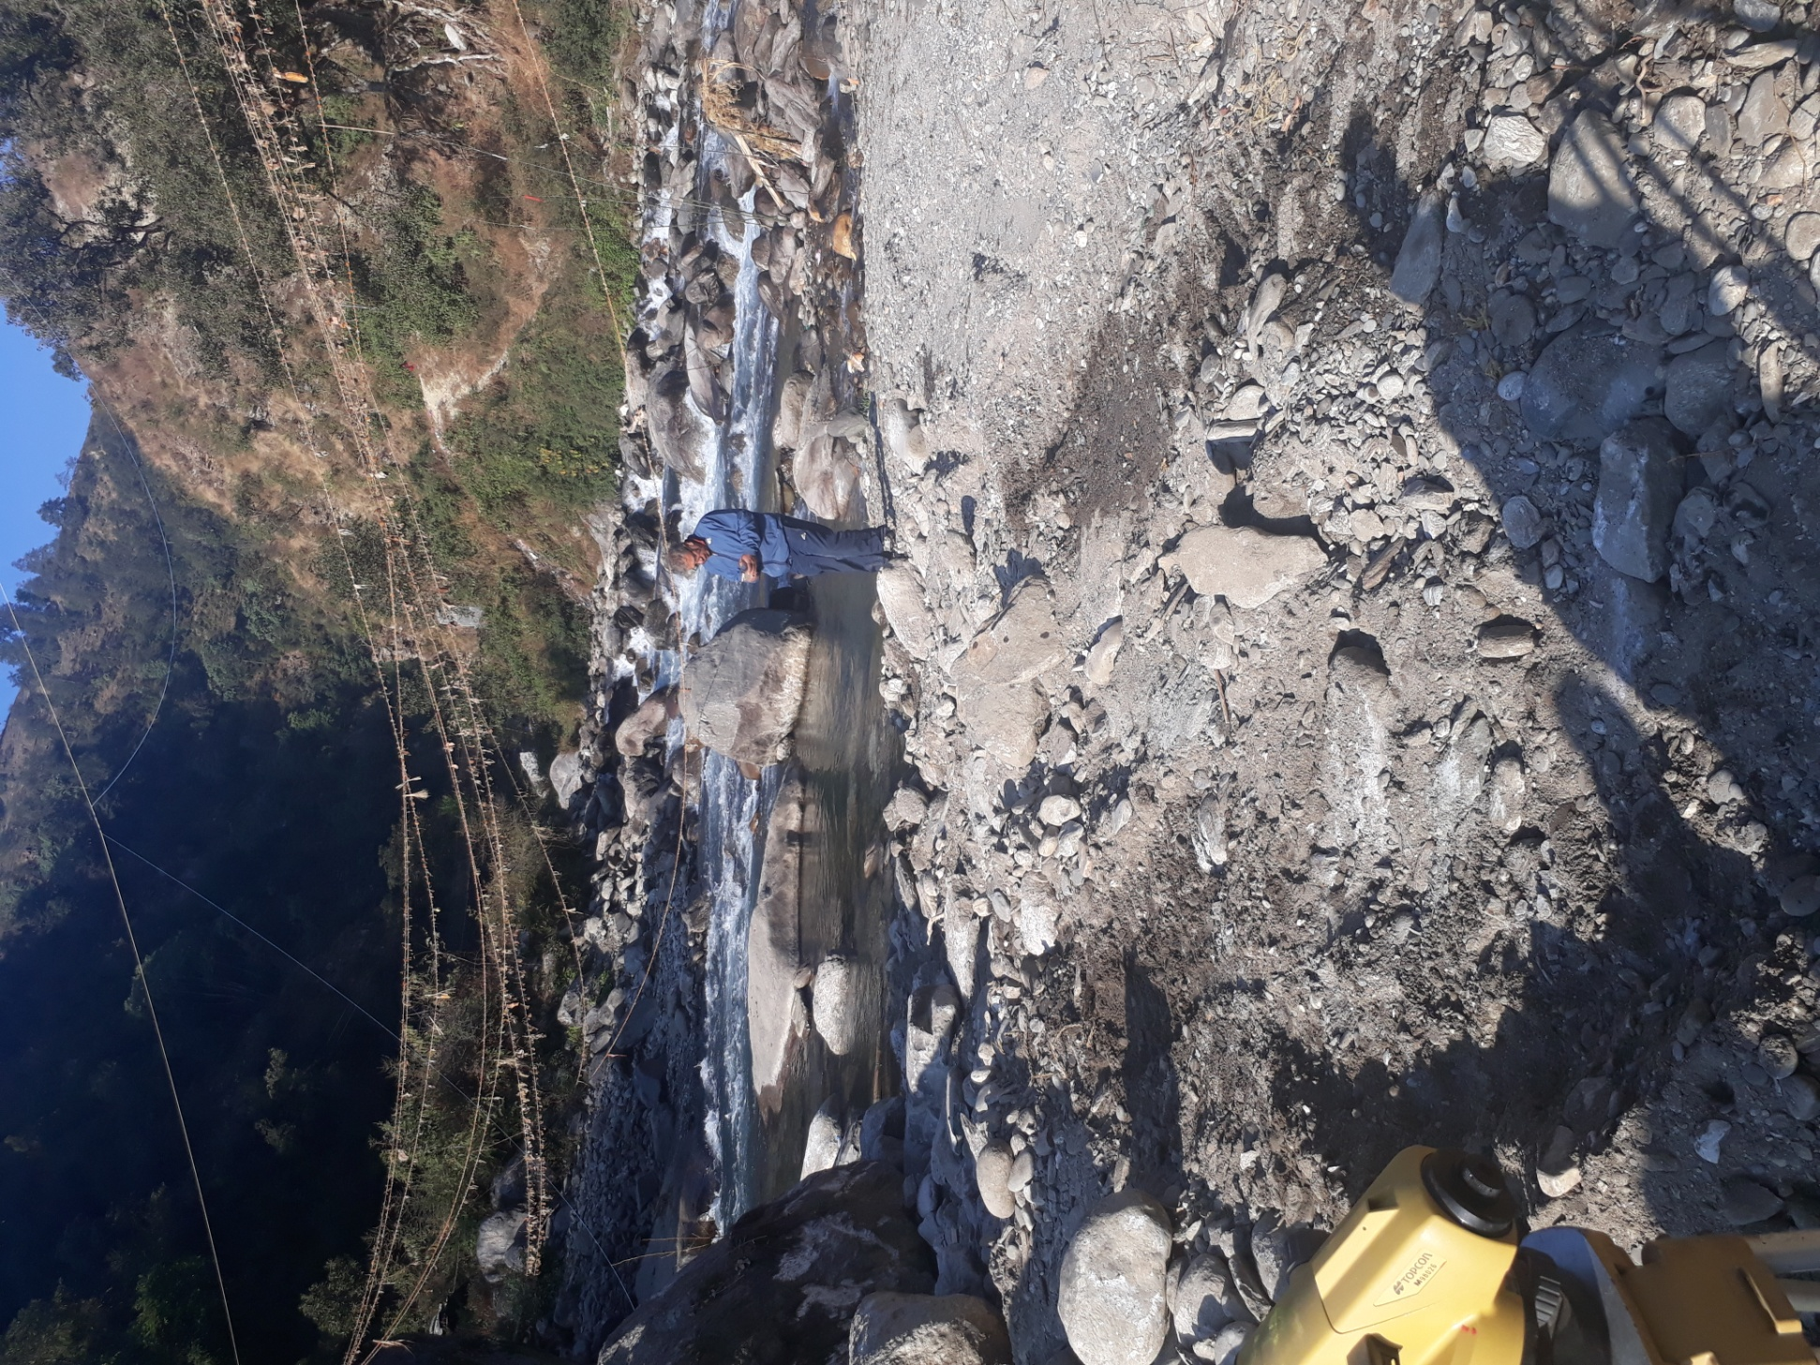
Sourng Khola (last accessible road from Kathmandu if we can arrange temporary store, If not Singati Bazar is 9 Km. far from this point.)

Regarding transportation we have talked several truckers. The fare is around Rs. 15/Kg from Kathmandu to site in 4-5 ton truck which is very high. If we arrange local tractors from Sorung Khola or Singati the cost will be decreased. If the local tractors/trucks claim high we have to arrange own tractor.

For the existing RCC building we can repair it with epoxy grouting and vertical iron beams support in necessary places. For the building we have to remove all 4” thick brick walls and rebuilt with 9” walls. The building has deficit of proper engineering design. So it shall be re-strengthening.

As per school authority CWIN Nepal is going to built 10 rooms. If we repair existing RCC building there will be 4 more rooms. We can build cost effective rooms from remaining amount. The basic cost of construction materials is extremely higher in that region, herewith attached rates provided by management committee. The revised estimate was done according to basic rates. Sorry to explain that our existing estimates of proposal is failed for that Project. We can construct only 2 class rooms and required maintenance in existing RCC building. We need to execute this project as soon as possible because management committee had announced to habitats of that area about IOWA as a helping agency for school.

With Kind Regards,
Er. Dilip Gasi

