Iowa Nepalese Association (INA)
INA Town Hall Meeting – Grimes Public Library, 200 N James St, Grimes, IA 50111 10/08/2017 3:00 PM- 5:00PM
Meeting Purpose: Annual General Meeting 2017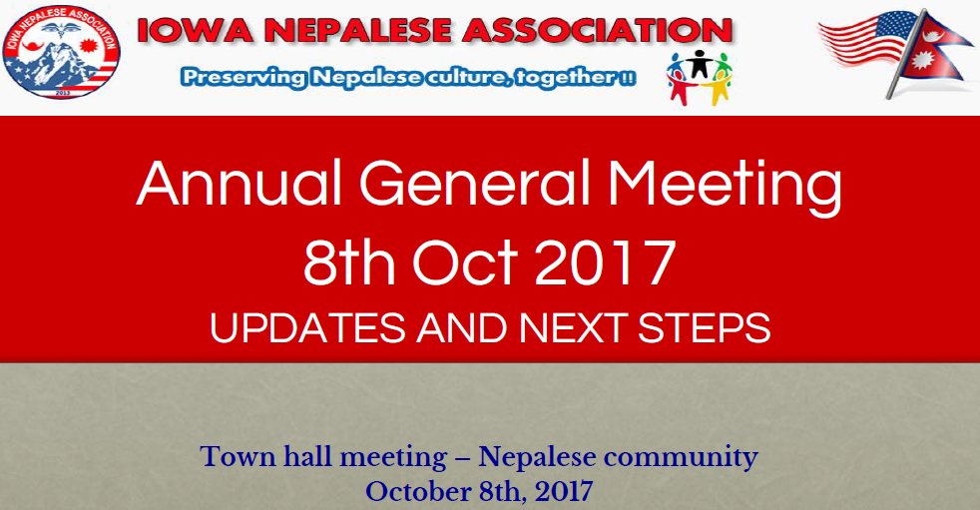

Invitees: All Iowa Nepalese Association Members
INA Members Present:

Kapil Limbu
Krishna Pandit
Prajwol Gopali
Sanjay Shrestha
Bhavesh Shrivastav
Bishwas Bhattarai
Ajay Bhattarai
Atma R. Upreti
Pradip R. Sthapit
Rachayita Karki
Madan Thapa
Bipin Tamrakar
Sanjay Ghimire
Meeting Minutes:

- Krishna (2016-2017 Treasurer) presented the Financial Report:

- INA 2016-2017 Board updated on Earthquake and Flood donation

- Election Chair Atma R Upreti announced Election Results for 2017-2018 board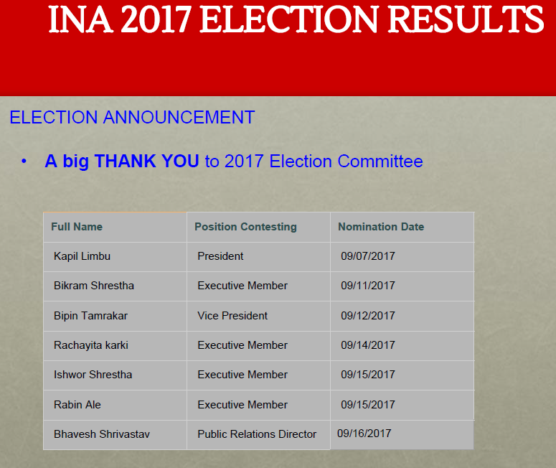

- Reviewed Original By-Laws and voted on proposed amendments. All Original By-Laws will stand as they are today, but following By-Laws amendments have been passed in AGM and will be effectively implemented as of 10/08/017:
  - Article I:
    - The principal office address needs to be updated.( Newly elected board member meeting will decide and incorporate the decision here)
  - Article IV, Section 3:
    - Original By-Law: 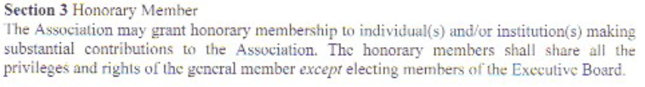
1st Amendment:
Section 3 Honorary Member
The Association may grant honorary membership to individual(s) and/or institution(s) making substantial contributions to the Association. The honorary members shall share all the privileges of the general member except electing members and/or contesting in the Executive Board.
  - Article VII
- Section 3:
    - Original By-Law:
1st Amendment:
Section 3 To run for election for any Executive Board position, the candidate(s) must be a general member of the Association for at least a year and should be an active member.
- Section 4:
- Original By-Law: 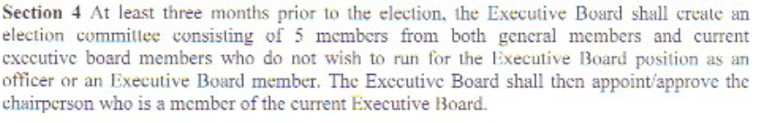
1st Amendment:
Section 4 At least two months prior to the election, the Executive Board shall create an election committee consisting up to 5 members. The Executive Board shall then appoint/approve the chairperson.

- Section 5:
- Original By-Law: 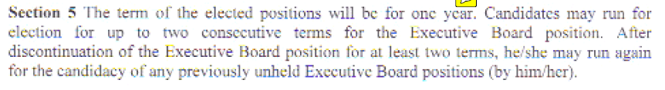 1st Amendment:
Section 5 The term of the elected positions will be for two years. Candidates may run for election for up to two consecutive terms for the same Executive Board position.

- A new Section 10 under Article VII is being added :
Section 10: Shall there be no self-nomination for any position(s), the newly elected board reserves the right to fulfill the vacant position(s) no later than 30 days of the initial Board meeting and the Board shall make it public within 7 days of the decision.

- SPECIAL PROVISION under Article VII will be permanently deleted from the By-Laws.
  - Article IX, Section 3:
      - Original By-Law: 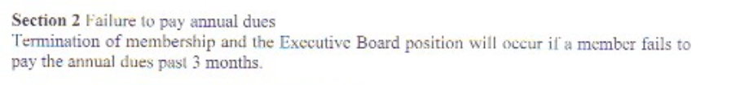
1st Amendment:
Suspension of membership and the Executive Board position will occur if a member fails to pay the annual dues past 3 months.

  - Article X, Section 3:
      - Original By-Law: 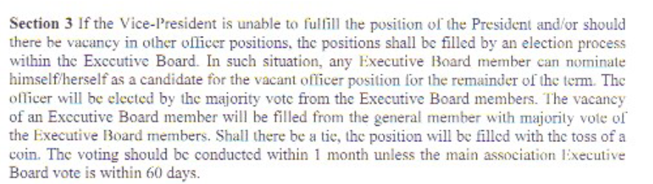

1st Amendment:
Section 3 If the Vice-President is unable to fulfill the position of the President and/or should there be vacancy in other officer positions, the positions shall be filled by an election process within the Executive Board. In such situation, any Executive Board member can nominate himself/herself as a candidate for the vacant officer position for the remainder of the term. The officer will be elected by the majority vote from the Executive Board members. If no Executive Members volunteer for the
vacant officer position, current board can nominate anyone from the general member who is willing to take that position. In case of multiple nomination by board, decision should be made by majority vote of executive board member. Shall there be a tie, the position will be filled with the toss of a coin.

Note: URL for Original By-Laws
http://www.iowanepaleseassociation.org/download/bylawsNAmendments/INA%20By-Laws.pdf

Please let us know if you have any concerns.

Thanks,
Iowa Nepalese Association (INA)

